Poznan, 9 March 2023
The block of the Meble Polska and Home Decor trade fairs is as strong as before the pandemic

The block of Meble Polska and Home Decor furniture fairs regained its pre-pandemic condition. This year's edition of the fair, which took place in Poznan on 21–24 February 2023, was similar in size to the record event held in 2020. The number of participants increased by 19.6%, compared to the fair organised in May 2022.

Fifty-one percent visitors from abroad
A high percentage of traders from abroad is already a standard at this event. Every year, thousands of representatives of foreign purchasing groups, wholesalers, as well as furniture and interior design showroom chains from all over the world visit the fair. It was no different this time – the MEBLE POLSKA and HOME DECOR fairs were attended by visitors from 71 countries.
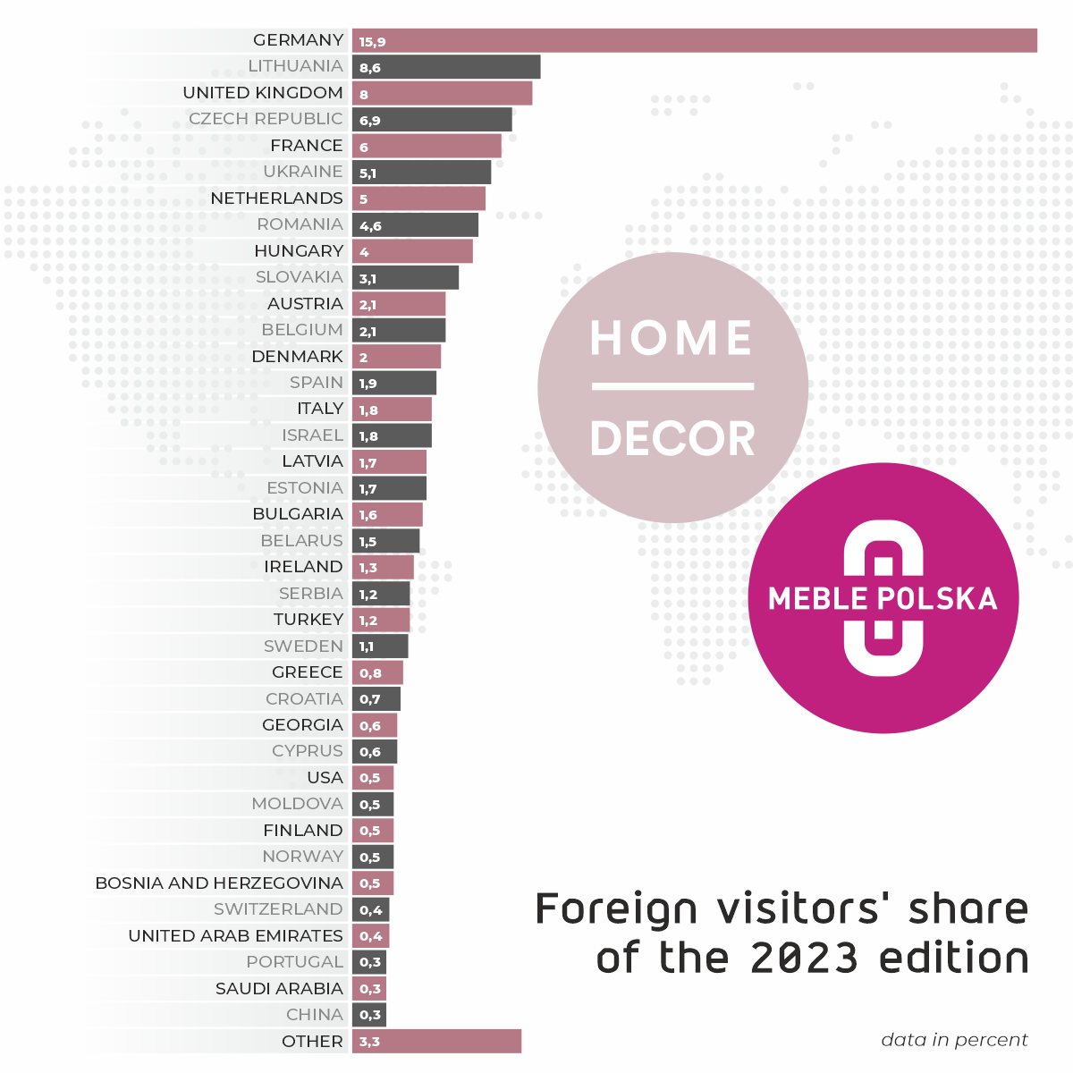
The largest group were merchants from Germany (15.9% of foreign merchants). Another significant group of fair guests came from Lithuania, Great Britain, the Czech Republic, France, Ukraine and the Netherlands. The fair stands were also visited by representatives of trade from such markets as the United States, Israel and the United Arab Emirates.
The fair was also visited by merchants from such remote countries as: Angola, Saudi Arabia, Australia, China, French Guiana, India, Jordan, Kenya, Costa Rica, Kuwait, Lebanon, Libya, Mali, Mauritius, Mongolia, Nigeria, Palestine, Peru, Sri Lanka, Uzbekistan and Ivory Coast.
The total number of fair participants amounted to 13,744 people. According to the registration data 51% of all visitors came from abroad.
Exhibition in 7 halls
The exhibition was organised in the MTP Poznan Expo halls 3, 3A, 5, 5A (Home Decor), 6, 8 and 8A, covering the total area of 55,000 square meters. In the Home Decor hall, the exhibitors presented the latest collections of standing and wall decorations, lighting, textiles, ceramics, home audio and video equipment, kitchen and bathroom accessories, and other decorative elements. And in furniture halls visitors could see products from all price segments: upholstered furniture, case furniture made of furniture board and solid wood, chairs, tables and mattresses.
In total, 263 companies from 14 countries presented their offer at MEBLE POLSKA and HOME DECOR 2023.
Training for traders
The fair was accompanied by interesting seminars, lectures and discussion panels. Traditionally, on the first day B+R Studio presented its report 'Polish Furniture Outlook – perspectives for the Polish furniture industry'.
The whole day was devoted to the owners of interior design stores. The lectures provided a lot of practical knowledge – especially important now, when sales are becoming more and more difficult.
A series of interesting lectures was also prepared by Unity SA. They presented global trends in business development and solutions supporting sales and digitisation of companies in the furniture and interior design industry. In turn, the lecture involving eco-design held by the Łukasiewicz Research Network – Poznan Institute of Technology, perfectly matched the trend of sustainable production, which may be an opportunity for Polish manufacturers to increase their competitiveness.
In response to the growing interest of Polish companies in the American market, experts from the Polish Investment and Trade Agency were invited to provide valuable tips on how to export products to the USA and Canada. During the panel discussion, participants had the opportunity to learn more about the business culture, customer expectations, logistics and free trade agreements in both countries.

Meble Polska and Home Decor 2024
The next edition of MEBLE POLSKA and HOME DECOR will be held as usual in the last week of February – on 20–23 February 2024. – We have a lot of ideas regarding the formula of next year's interior design exhibition. We hope that the proposed changes in the formula of the event will attract many new exhibitors to Poznań – says Dagmara Suprun, director of the Home Decor fair.

